Windows Server 2019 Installation and Preparation using Hyper-V

Learning objective:

1. Enabling Hyper-V for use on Windows 10/11 pro
2. Install and prepare Windows Server 2019 in Hyper-V.
3. Install Active directory and domain services
4. Create Organizational Units, Users and Groups in Active directory
5. Join Windows 10/11 to the domain
6. Enabling Hyper-V for use on your Windows 10/11 pro

Follow step by step provided in the following link to enable Hyper-V

[**https://techcommunity.microsoft.com/t5/itops-talk-blog/step-by-step-enabling-hyper-v-for-use-on-windows-10/ba-p/267945**](https://techcommunity.microsoft.com/t5/itops-talk-blog/step-by-step-enabling-hyper-v-for-use-on-windows-10/ba-p/267945)

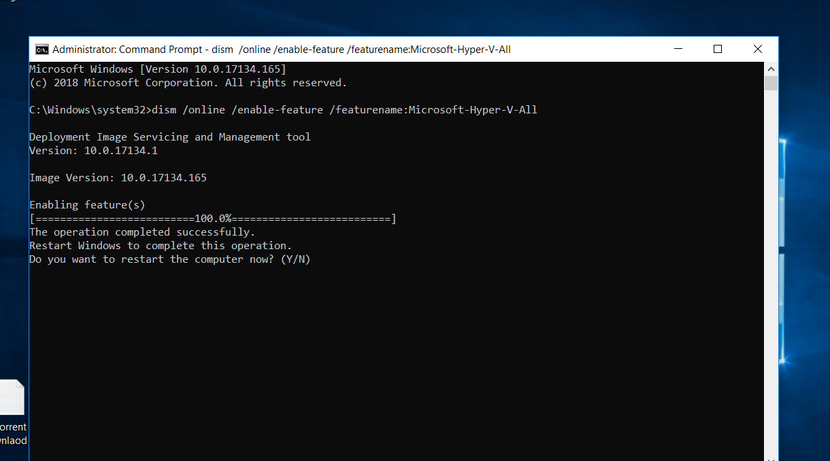

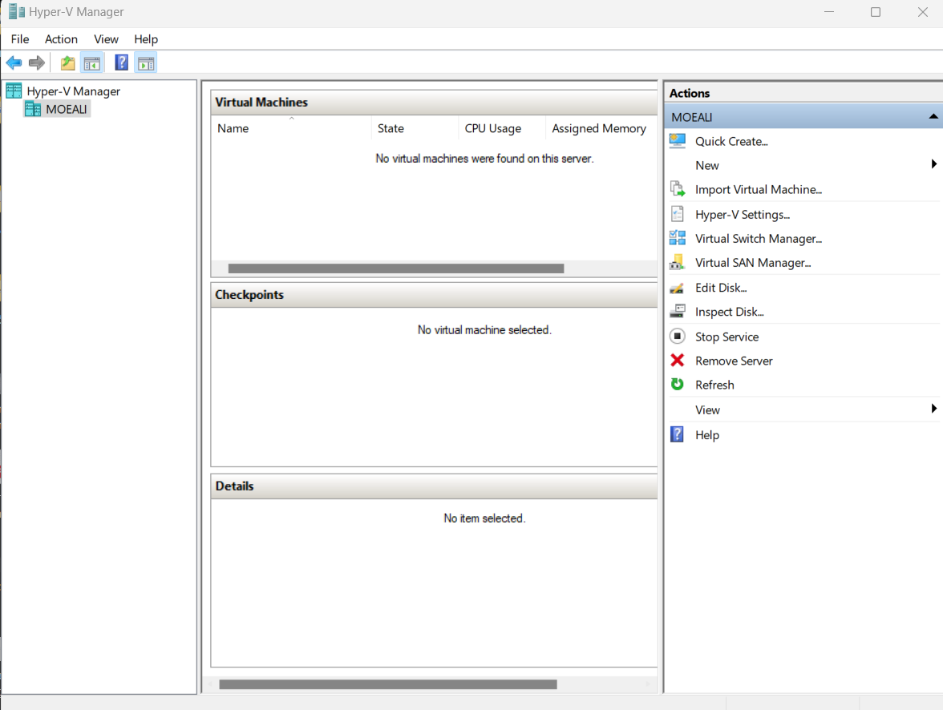

1. Install and prepare Windows Server 2019:
   * Visit the following link: [Download Windows Server 2019](https://info.microsoft.com/ww-landing-windows-server-2019.html) and download Windows Server 2019 **Standard** evaluation ISO file.
   * Use Hyper-V manager to create a new VM for Windows Server 2019.

You can use the following link:

[**https://www.youtube.com/watch?v=-Q9VUlY8bMg**](https://www.youtube.com/watch?v=-Q9VUlY8bMg)

Notes:

* During the installation of Windows Server 2019 choose **Desktop experience**
* After completing the installation, take a checkpoint (snapshot) of the virtual machine as a backup, in case you need it in the future. You can name the checkpoint 'Before installing Active Directory'
* Change the name of your server to: **ADPrimary or ADMaster**
  + Assign the IP address 192.168.10.10 to the server

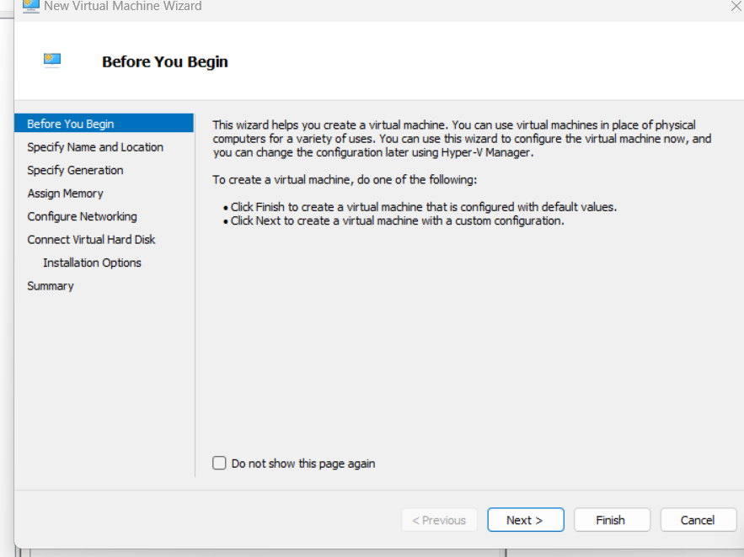

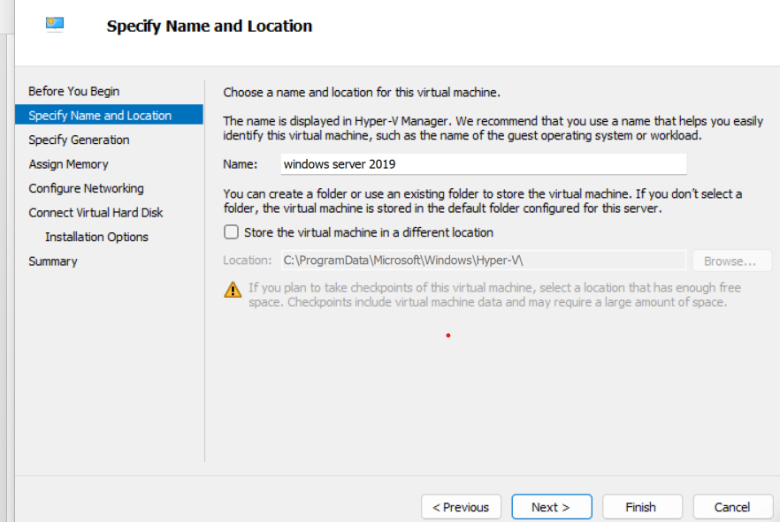

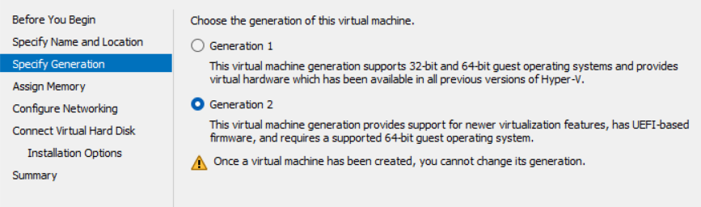

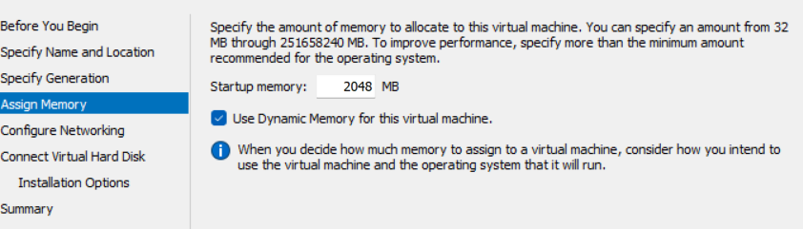

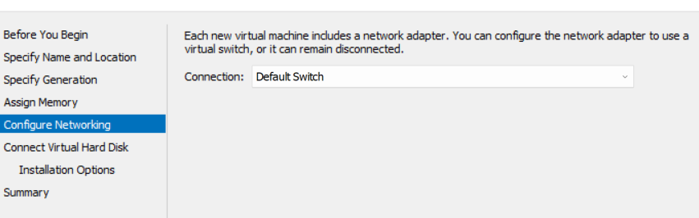

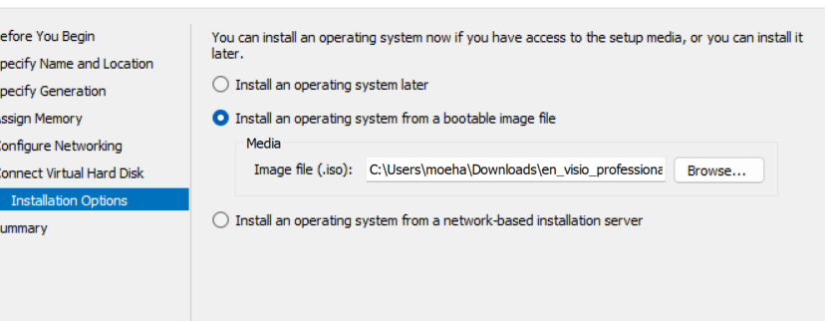

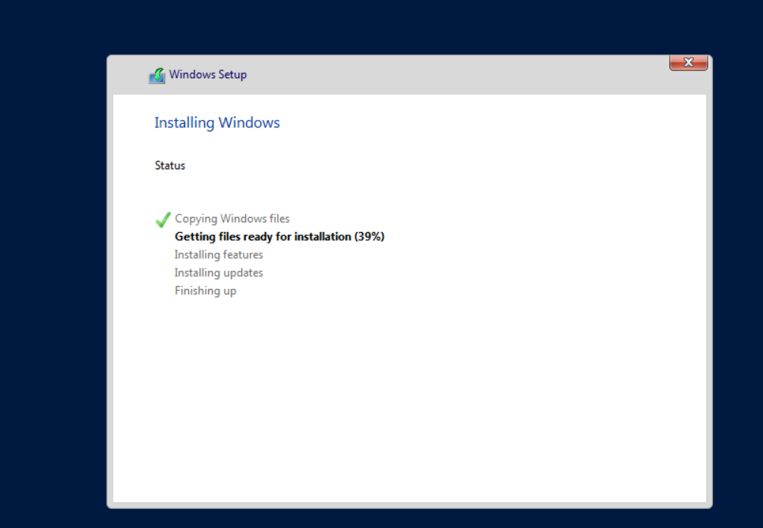

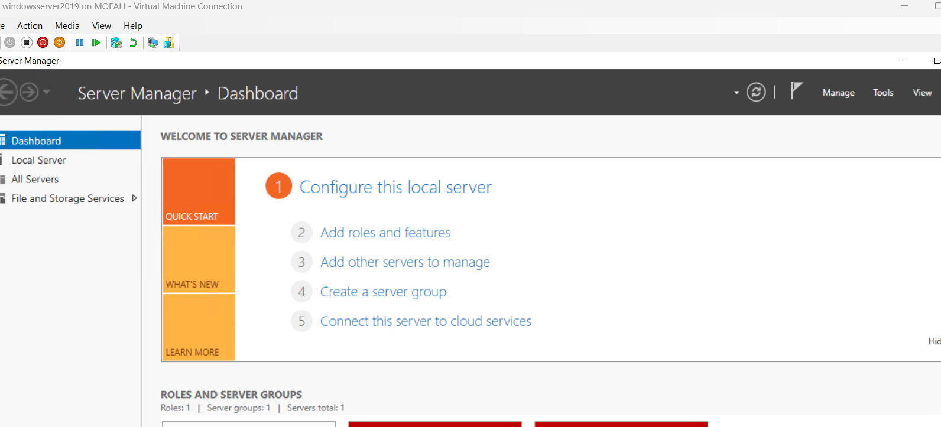

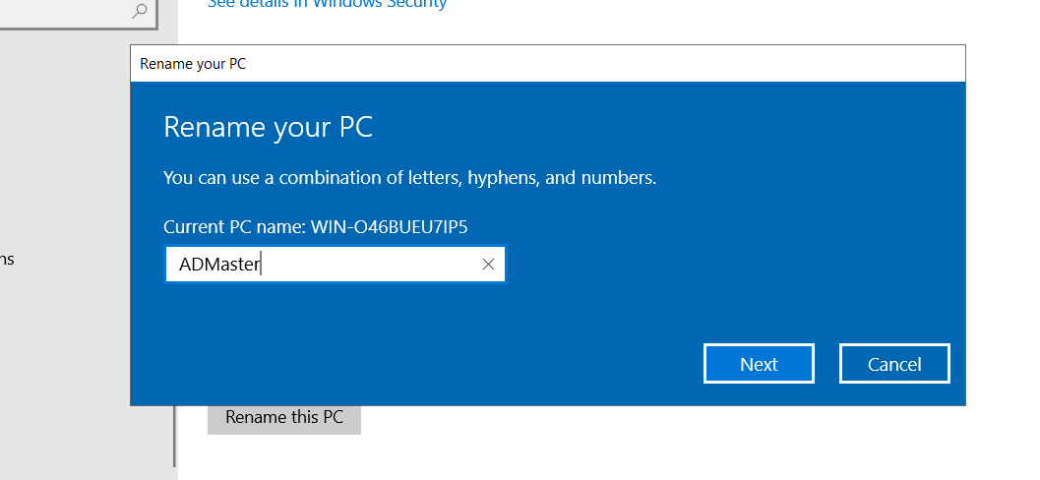

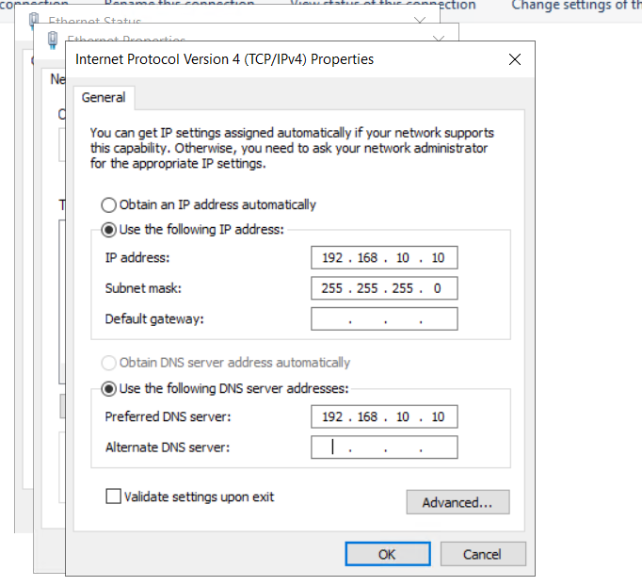

1. Install Active Directory Domain Services (ADDS) and, during the installation, choose '**StudentfirstName**.com' as your organization's name (domain service name).

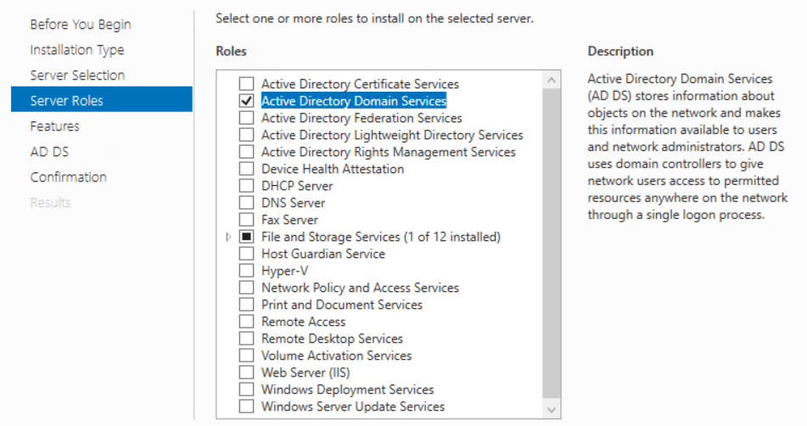

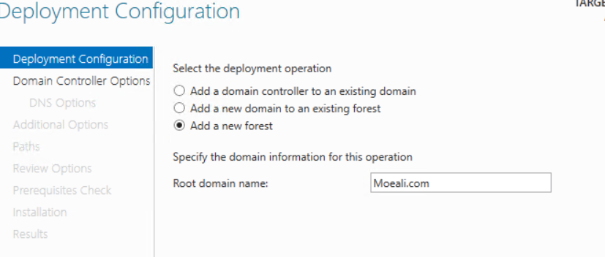

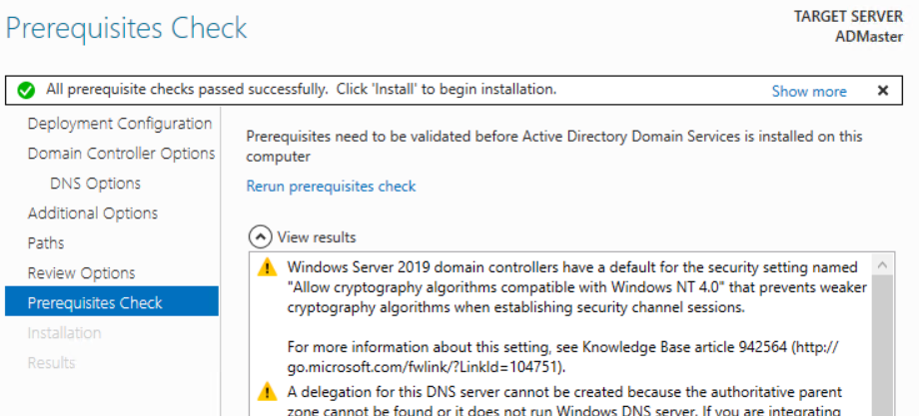

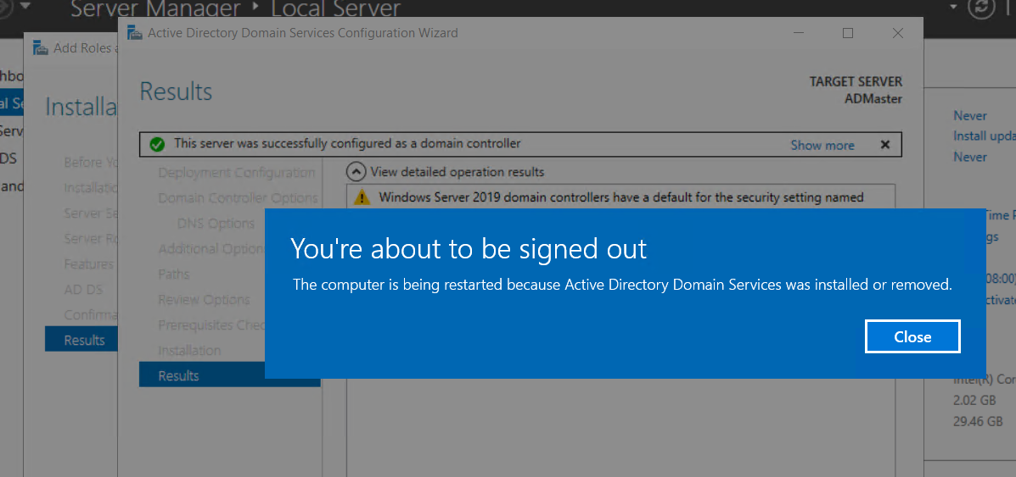

1. Create Organizational Units, Users and Groups in Active directory

**Create Organizational Units**

On the Server, create the following Organizational Units using **Active Directory Users and Computers**: Toronto, Edmonton

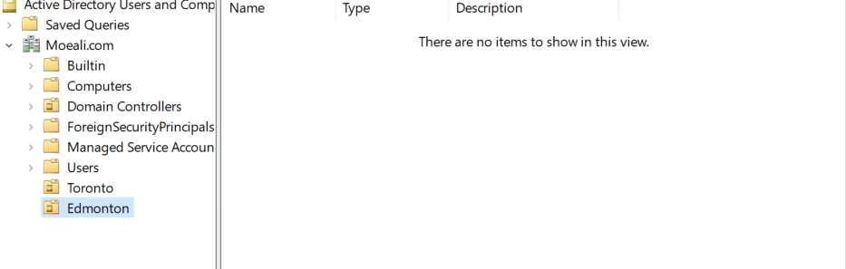

**Create Global Groups in the Domain**

1. On the Server, under the **Toronto** Organizational Unit, create the following Global Security Groups using **Active Directory Users and Computers**:
   * T_Marketing
   * T_HR
   * T_IT
   * T_Executives

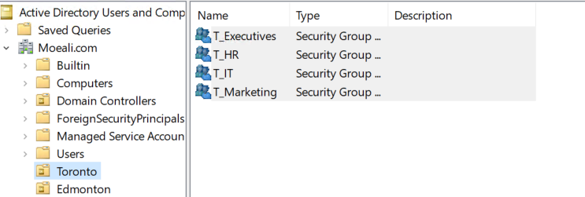

1. Create similar groups in the Edmonton OU, substituting **E** for Edmonton the **T** in each name.

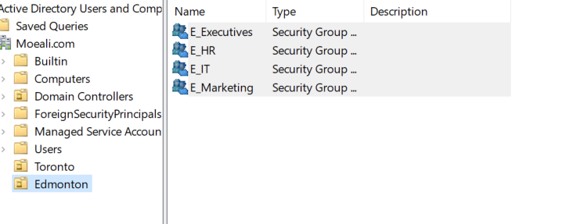

**Creating Domain User Accounts and assign them to the groups**

Note: Decide on a Naming Convention (e.g. wilma.flint or w.flint etc.) for the user accounts you will create in your domain. Use the default password for all users (newuser123!) and select the User must change password at next login

1. Create the following user accounts under the **Toronto OU** using Active Directory Users and Computers:
   * Bam Rubble – Member Of: T_Marketing
   * Wilma Flint – Member Of: T_HR
   * Khaled Jabbari – Member Of: T_IT
   * Slate Stewart – Member Of: T_HR and T_Executives

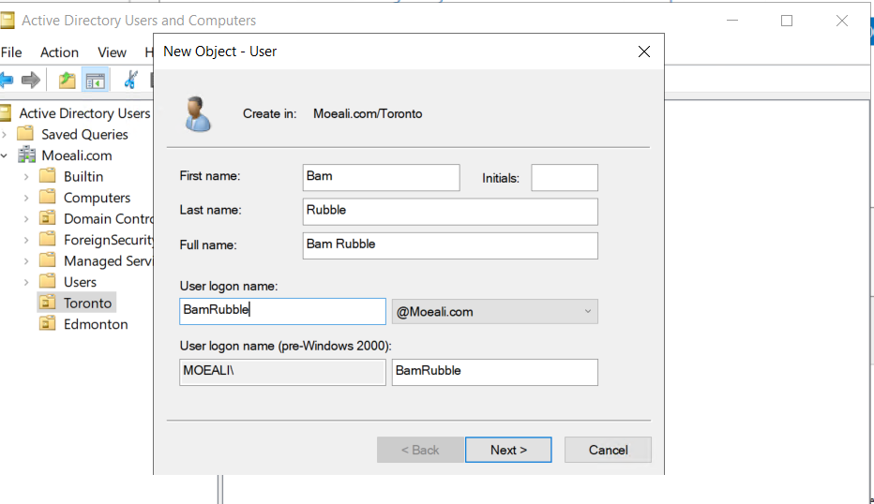 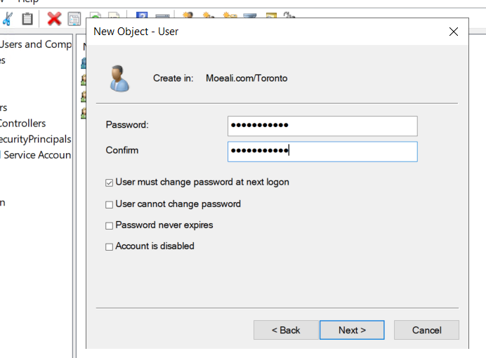

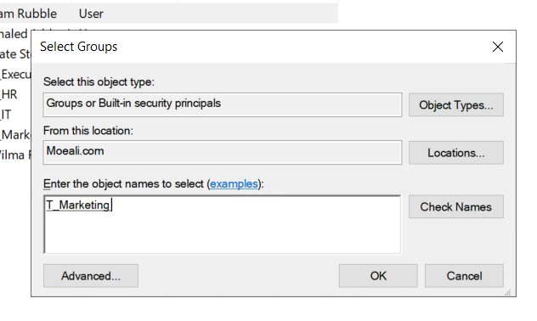 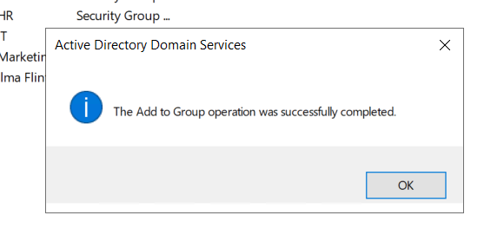

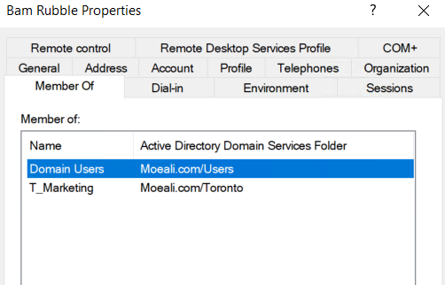 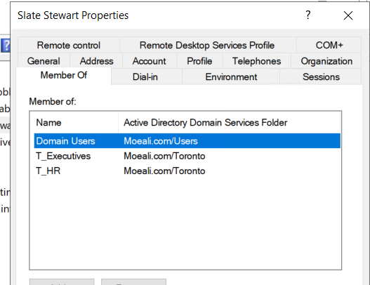

1. Create the following user accounts under the **Edmonton OU** using Active Directory Users and Computers:
   * Skye Blue– Member Of: E_Marketing
   * Staum Clowd– Member Of: E_HR
   * Mohammed Ahmed – Member Of: E_IT
   * Dee Zynah– Member Of: E_HR and E_Executives

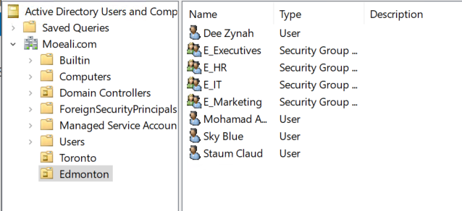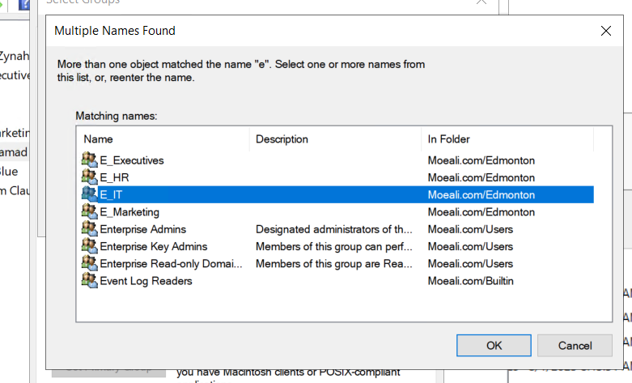

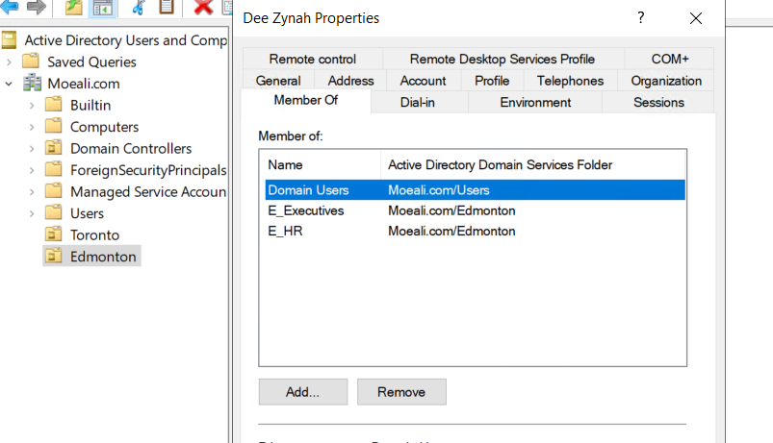

1. Install Windows 10/11 and join to ADDS
   * Create a new VM in Hyper-V for Windows client 10/11
   * After the installation is complete, connect the Windows 10/11 client to the same network as the server and assign the following IP address to the client:

IP address: 192.168.10.100

Subnet mask: 255.255.255.0

Default gateway: None

DNS: 192.168.10.10

* + Join Windows client 10/11 to the ADDS
  + Verify that the domain users you created can login using the client machine

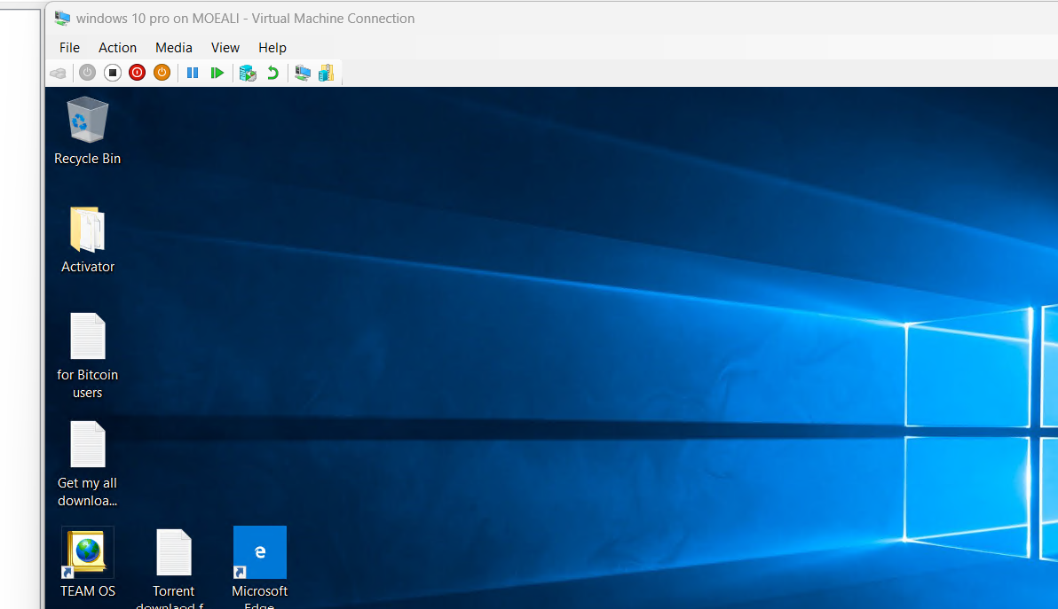 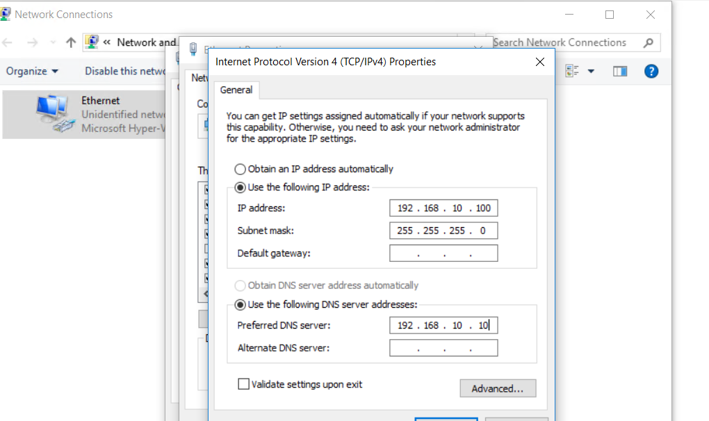

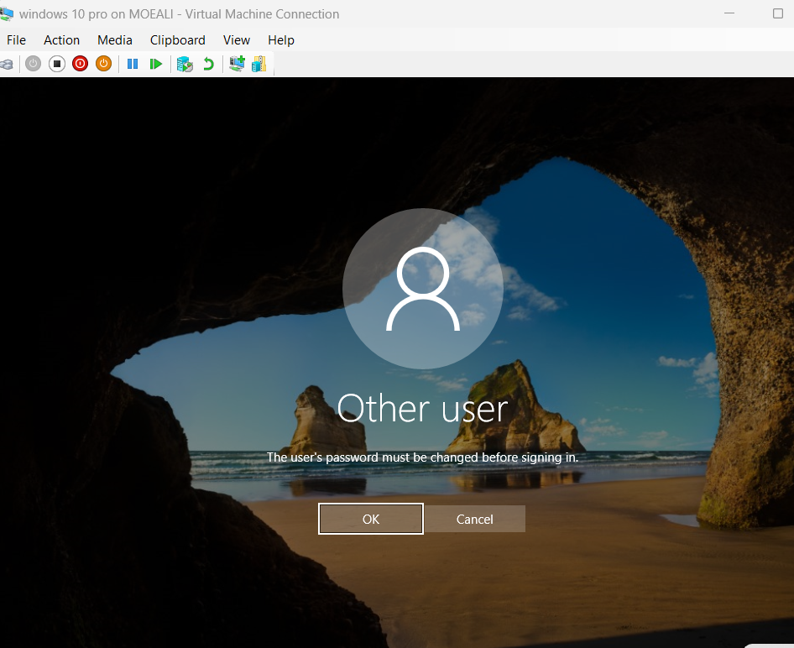 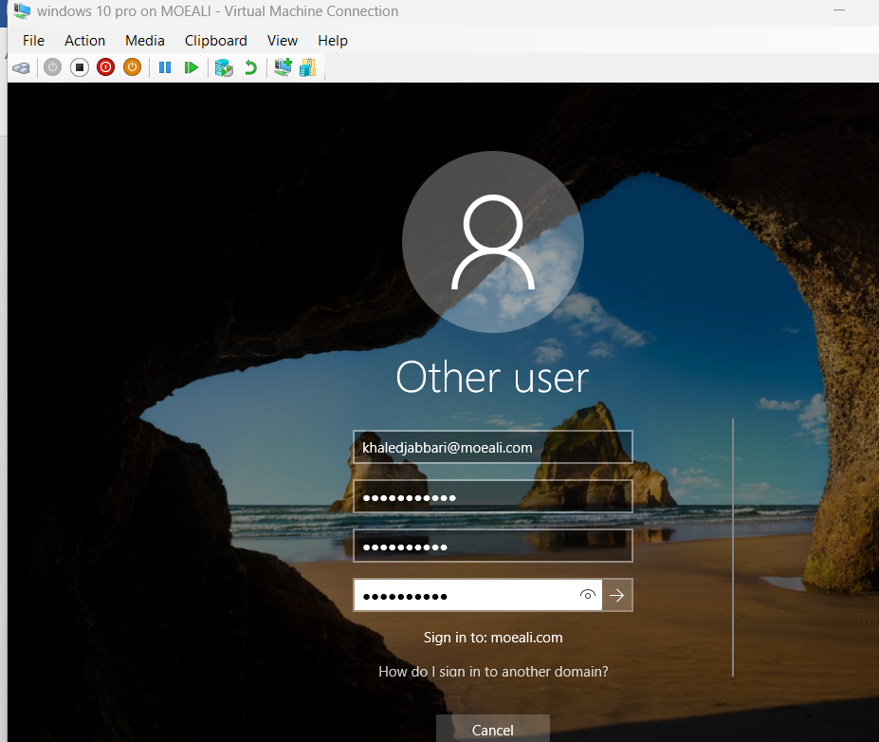

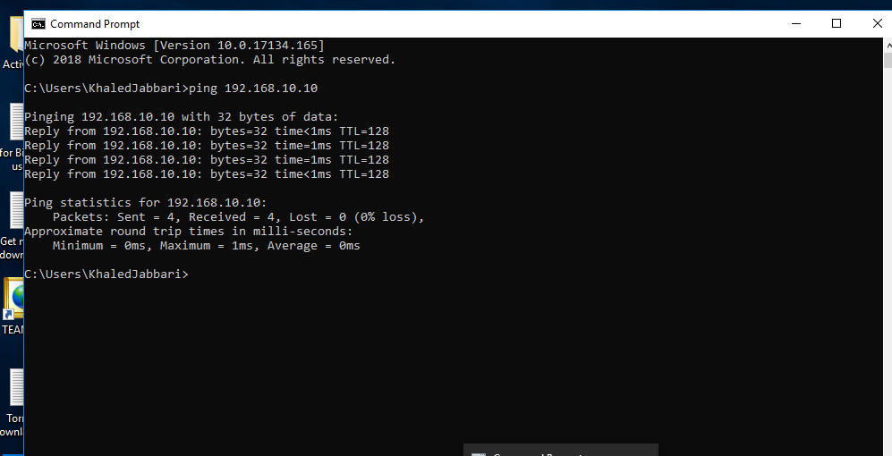

**Submission**

* Provide detailed documentation of each step performed during the installation and preparation process.
* Include screenshots, configuration settings, and any additional notes.

Students need to submit a detailed report, including screenshots, to describe what has been done and observed. Please provide explanations for any interesting or surprising observations. Late submissions of the assignment will result in a 10% deduction.

**Links**

<https://blog.foldersecurityviewer.com/windows-server-2022-installing-active-directory/>